In this investigation a process for measuring the relationship between two variables is examined. The measure is called the q-correlation coefficient.
To calculate the q-correlation coefficient
- Plot a scatter graph for the two variables.
- Determine the median for the values on the horizontal (x) axis.
- Determine the median for the values on the vertical (y) axis.
- Divide the region where the points occur into 4 quadrants by
  - Drawing a vertical line where x = median of values on the horizontal axis
  - Drawing a horizontal line where y = median of values on the vertical axis
- Label the quadrants e.g. A, B, C and D in the positions as shown on the graph below. The top right quadrant is always A, the top left is B, bottom left is C and bottom right is D.
- Count the points in each quadrant (do not count points on the dividing lines).
- Use the rule q-correlation coefficient = $\frac{\left(a+c\right)- (b+d)}{a+b+c+d}$ where a represents the number of points in quadrant A, b represents the number of points in quadrant B, c represents the number of points in quadrant C, and d represents the number of points in quadrant D.

Example: M1 and M2 represent the scores of ten students in two mental Maths tests.

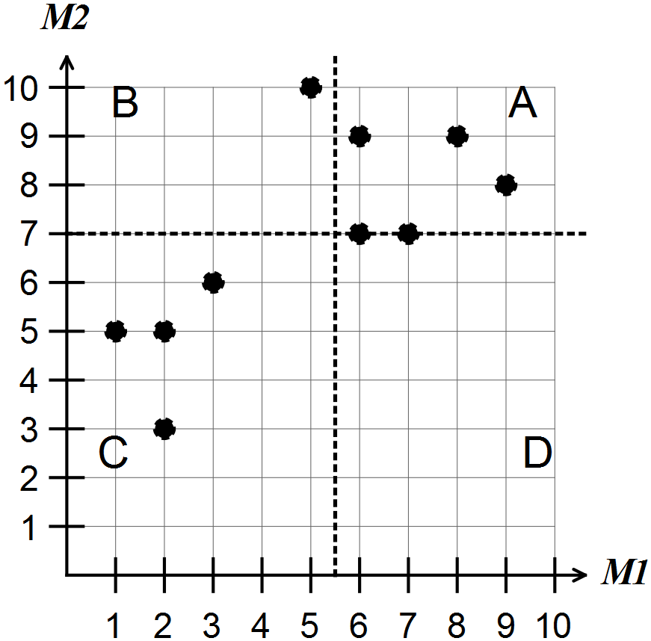

For the scatter graph shown above
- the median of M1 is 5.5
- the median of M2 is 7
- there are 3 points in A so a = 3. Similarly b = 1, c = 4, d = 0.
The points (6,7) and (7,7) are on a line and not counted in any quadrants.
Hence, the q-correlation coefficient is equal to
Note: Give q-correlations as fractions and decimals.
Question 1 (7 marks)

M3 and M4 represent students’ scores in Mental Maths tests

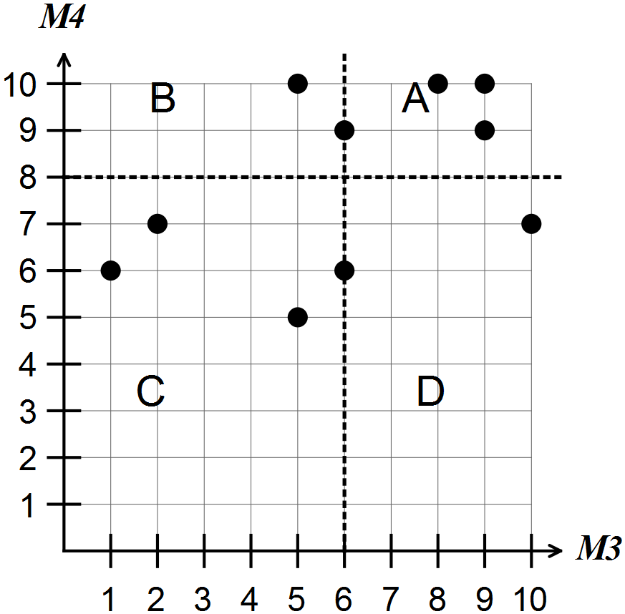

(a) How many students are represented? (1)

(b) What is the median for M3? (1)

(c) What is the median for M4? (1)

(d) How many students scored above the medians in both their tests?

In what quadrant are the points for these students located? (2)

(e) Determine the q-correlation coefficient for the relationship between M3 and M4.
(2)

Question 2 (7 marks)

The graph shows a sample of daily maximum temperatures and the number of pies sold at the canteen during lunch time at one particular school.

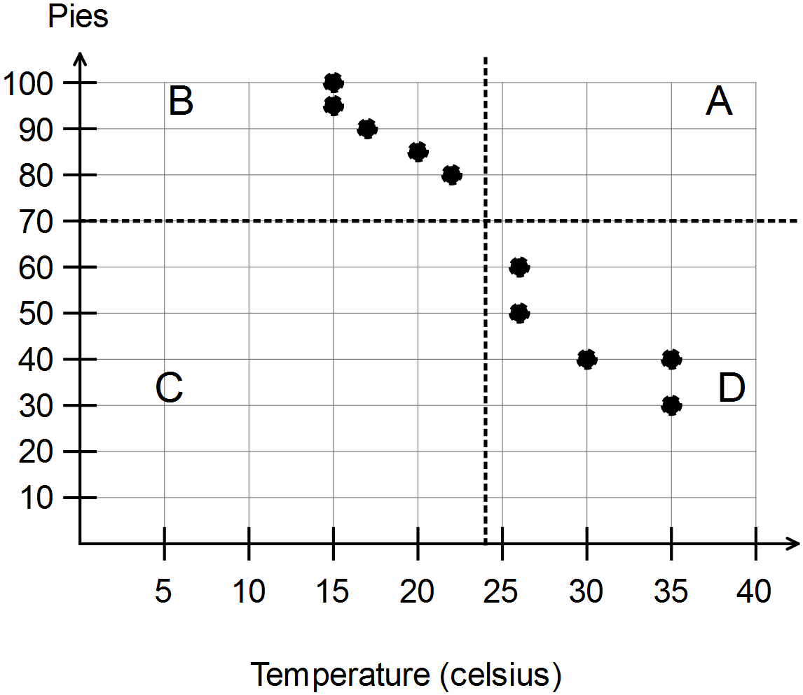

(a) Describe the relationship between the number of pies sold and the daily maximum temperature. (1)

(b) Determine the median number of pies sold at the canteen. (1)

(c) Explain why there are no points on the dotted lines on this graph. (2)

(d) Determine the q-correlation coefficient for the relationship between the number of pies sold and the daily maximum temperature. (2)

(e) Determine the highest value that a q-correlation coefficient can take. (1)
Question 3 (8 marks)

Students in each of the Years 1 to 12 were asked if they liked two particular sports. The percentages of students in each class liking the two different sports are shown on the scatter graph below.

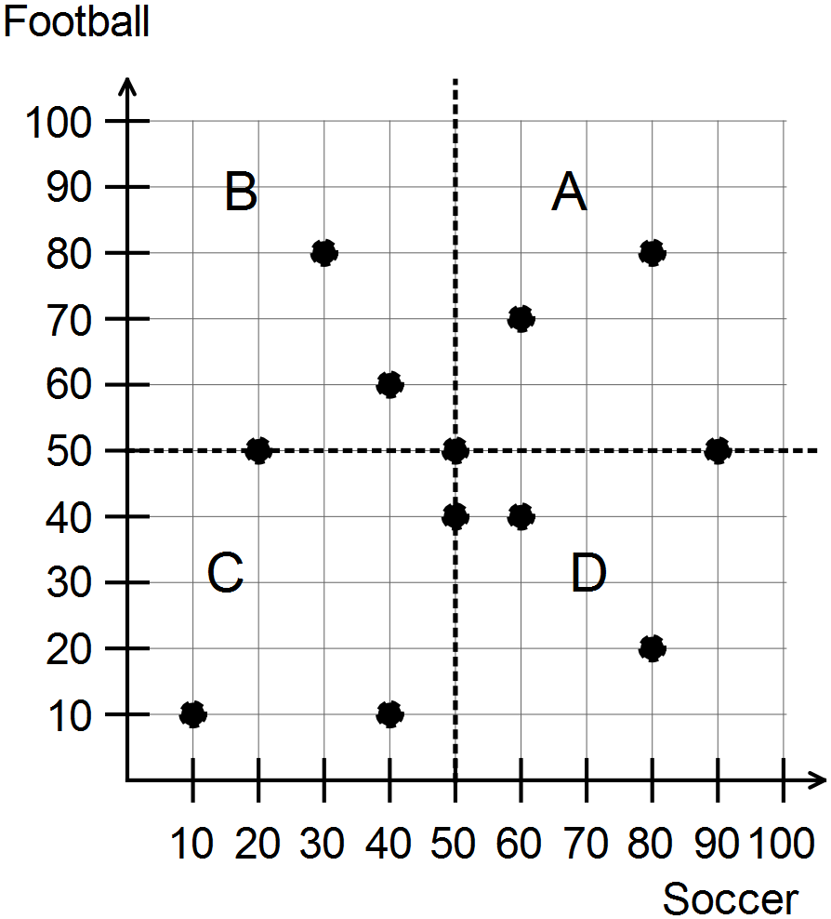

(a) What was the lowest percentage of students in any class liking football? (1)

(b) In any one class what was the highest percentage of students liking either sport?
(1)

(c) Describe what the point (50, 50) represents. (2)

(d) Determine the q-correlation coefficient for the relationship between the percentage of students liking football and the percentage of students liking soccer. (2)

(e) From the points on the scatter graph, what appears to be the relationship between the percentage of students liking football and the percentage of students liking soccer in each class? Justify your answer. (2)

Question 4 (7 marks)

In this question the process of determining the four quadrants will be further examined.

The following table shows the mental maths scores (out of 10) of two different tests for 10 students.

Student | 1 | 2 | 3 | 4 | 5 | 6 | 7 | 8 | 9 | 10
Test 1 | 1 | 2 | 6 | 6 | 7 | 10 | 8 | 5 | 5 | 8
Test 2 | 2 | 3 | 5 | 4 | 5 | 9 | 7 | 6 | 4 | 8

(a) Represent these data as a scatter graph on the axes below. (2)

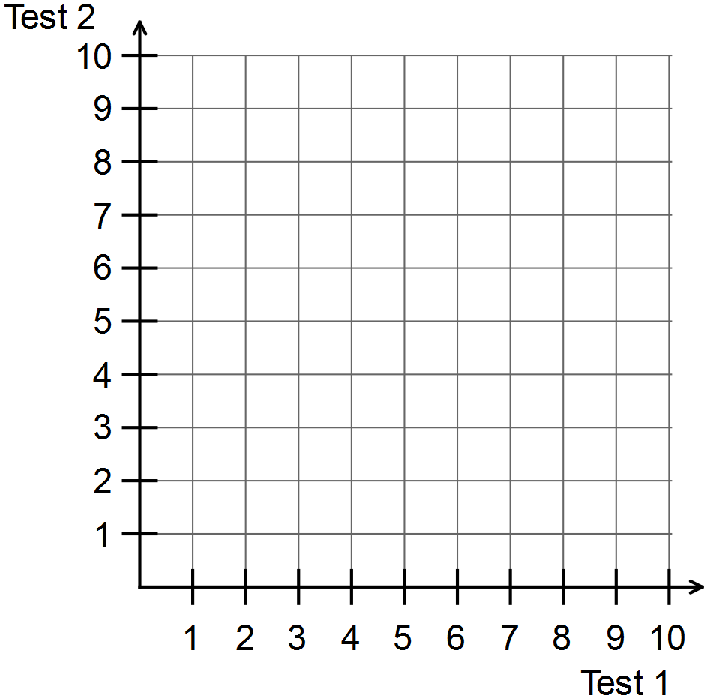

(b) Calculate the median of the Test 1 scores. (1)

(c) Calculate the median of the Test 2 scores. (1)

(d) Draw a vertical line to represent the location of the median for Test 1.
[Hint: consider the vertical lines in questions 1-3] (1)

(e) Draw a horizontal line to represent the location of the median for Test 2.
[Hint: consider the horizontal lines in questions 1-3] (1)

(f) Label the four quadrants as A, B, C and D. (1)
Question 5 (12 marks)

The following table shows the maximum wind speeds (km/h) and the maximum temperatures (degrees Celsius) for the first day of each of the last 12 months.

Month | 1 | 2 | 3 | 4 | 5 | 6 | 7 | 8 | 9 | 10 | 11 | 12
Wind speed | 31 | 22 | 22 | 33 | 30 | 31 | 33 | 35 | 39 | 57 | 43 | 28
Maximum  temperature | 22 | 21 | 23 | 24 | 24 | 29 | 31 | 25 | 29 | 34 | 31 | 28

Use the process described in the previous questions to

(a) draw a scatter graph to show the relationship between the wind speed and the maximum temperature (3)

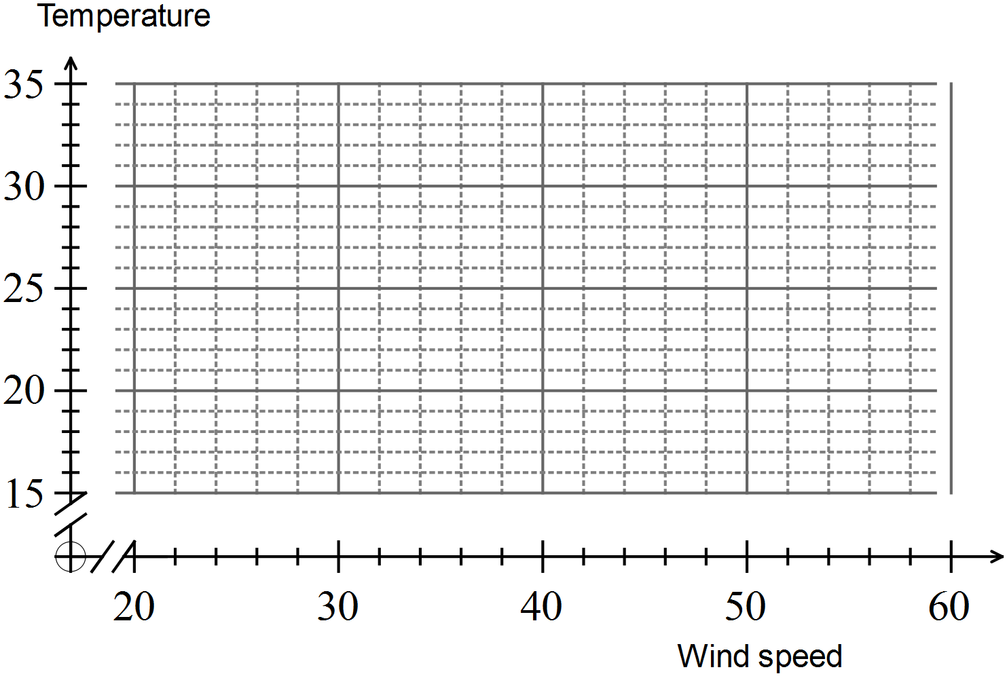

(b) Describe the relationship between maximum wind speed and maximum temperature referring to the location of the points to justify conclusions.
(3)
(c) divide the region of the plotted points into 4 labelled quadrants (4)

(d) calculate the q-correlation coefficient for the relationship between maximum wind speed and maximum temperature. (2)

Question 6 (9 marks)

(a) You are given a set of possible values for the q-correlation coefficient.
(6)
-1 -0.8 -0.6 0.1 0.5 0.9

Which of these values is most likely in each of the six situations given? (You can use the coefficients more than once)

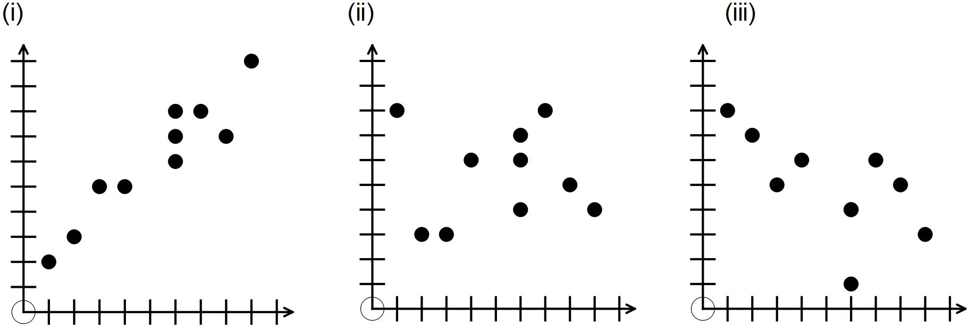

(iv) there is little or no relationship between the two variables

(v) there is a very strong positive linear relationship

(vi) as one variable increases the other decreases and the points lie in a straight line.

(b) State one possible advantage of using the q-correlation coefficient to determine the strength of a relationship between two variables. (1)

(c) State two possible disadvantages of using the q-correlation coefficient to determine the strength of a relationship between two variables. (2)

End of questions

